Strategy Pattern

Strategy pattern is used when we have multiple algorithm for a specific task and client decides the actual implementation to be used at runtime.
Strategy pattern is also known as Policy Pattern. We defines multiple algorithms and let client application pass the algorithm to be used as a parameter. One of the best example of this pattern is Collections.sort() method that takes Comparator parameter. Based on the different implementations of Comparator interfaces, the Objects are getting sorted in different ways.

Strategy Design Pattern Important Points
- We could have used composition to create instance variable for strategies but we should avoid that as we want the specific strategy to be applied for a particular task. Same is followed in Collections.sort() and Arrays.sort() method that take comparator as argument.
- Strategy Pattern is very similar to State Pattern. One of the difference is that Context contains state as instance variable and there can be multiple tasks whose implementation can be dependent on the state whereas in strategy pattern strategy is passed as argument to the method and context object doesn’t have any variable to store it.
- Strategy pattern is useful when we have multiple algorithms for specific task and we want our application to be flexible to choose any of the algorithm at runtime for specific task.

Strategy Design Pattern Class Diagram
For our example, we will try to implement a simple Shopping Cart where we have two payment strategies – using Credit Card or using PayPal.
First of all we will create the interface for our strategy pattern example, in our case to pay the amount passed as argument.
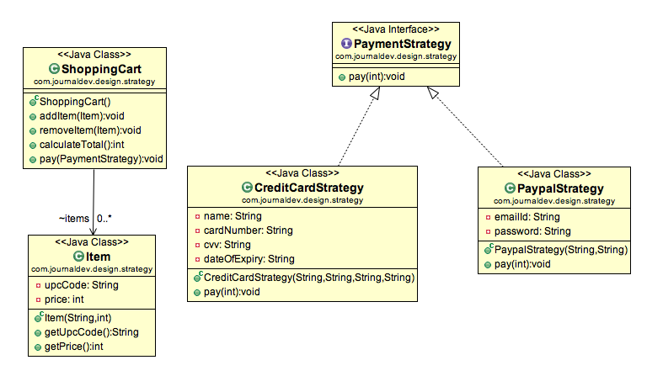

package com.test.design.pattern.strategy;

@FunctionalInterface
public interface PaymentStrategy {
public void pay(int amount);
}

package com.test.design.pattern.strategy;

public class PaypalStrategy implements PaymentStrategy {

private String email;
private String password;

public String getEmail() {
return email;
}

public void setEmail( String email ) {
this.email = email;
}

public String getPassword() {
return password;
}

public void setPassword( String password ) {
this.password = password;
}

@Override
public void pay( int amount ) {
System.out.println("Amount rs "+amount+" paid by paypal wallet");
}

}

package com.test.design.pattern.strategy;

public class CreditCardStrategy implements PaymentStrategy {

private String creditCardNumber;
private String cardHolderName;
private String cvv;
private String dateOfExpairy;

public String getCreditCardNumber() {
return creditCardNumber;
}

public void setCreditCardNumber( String creditCardNumber ) {
this.creditCardNumber = creditCardNumber;
}

public String getCardHolderName() {
return cardHolderName;
}

public void setCardHolderName( String cardHolderName ) {
this.cardHolderName = cardHolderName;
}

public String getCvv() {
return cvv;
}

public void setCvv( String cvv ) {
this.cvv = cvv;
}

public String getDateOfExpairy() {
return dateOfExpairy;
}

public void setDateOfExpairy( String dateOfExpairy ) {
this.dateOfExpairy = dateOfExpairy;
}

@Override
public void pay( int amount ) {
System.out.println("Amount rs "+amount+" paid by credit card");
}

}
package com.test.design.pattern.strategy;

public class Item {
private String upcCode;
private int price;

public String getUpcCode() {
return upcCode;
}

public void setUpcCode( String upcCode ) {
this.upcCode = upcCode;
}

public int getPrice() {
return price;
}

public void setPrice( int price ) {
this.price = price;
}

}

package com.test.design.pattern.strategy;

import java.util.ArrayList;
import java.util.List;

public class ShoppingCart {

List<Item> items = new ArrayList<>();

public void addItem( Item item ) {
this.items.add( item );
}

public void removeItem( Item item ) {
this.items.remove( item );
}

public int calculatBill() {
int totalAmtToBePay = items.stream().mapToInt( e -> e.getPrice() ).sum();
System.out.println(totalAmtToBePay);
return totalAmtToBePay;
}

public void payBill(PaymentStrategy paymentStrategy){
paymentStrategy.pay( calculatBill() );
}
}

package com.test.design.pattern.strategy;

public class TestStrategyDesignPattern {

public static void main(String args[]){

ShoppingCart cart = new ShoppingCart();

Item item = new Item();
item.setUpcCode( "12345" );
item.setPrice( 20 );
cart.addItem( item );

Item item1 = new Item();
item1.setUpcCode( "34567" );
item1.setPrice( 40 );
cart.addItem( item1 );

Item item2 = new Item();
item2.setUpcCode( "14377" );
item2.setPrice( 30 );
cart.addItem( item2);

Item item3 = new Item();
item3.setUpcCode( "8777" );
item3.setPrice( 50 );
cart.addItem( item3);

PaypalStrategy paypalStrategy = new PaypalStrategy();

paypalStrategy.setEmail( "sanjeev@gmail.com" );
paypalStrategy.setPassword( "12345" );

cart.payBill( paypalStrategy );

cart.removeItem( item3 );

CreditCardStrategy cardStrategy = new CreditCardStrategy();

cardStrategy.setCardHolderName( "Sanjeev Rai" );
cardStrategy.setCreditCardNumber( "1231313" );
cardStrategy.setCvv( "abc" );
cardStrategy.setDateOfExpairy( "5/2019" );

cart.payBill( cardStrategy );

}

}

